CUSTOMER SEGMENTATION
(CDACL - 002)

Submitted by:

Name: Bandaru Harika Hasini

Roll No: CA11202516329
Course: CDA

Institute Name: Datamites

CERTIFICATE
This is to certify that Ms. BANDARU HARIKA HASINI (Roll No: CA11202516329) has successfully completed the project titled "Customer Segmentation" as part of the Data Analytics Program. The project was undertaken under proper guidance and supervision and is submitted in partial fulfillment of the requirements of the course.
The objective of this project was to analyze customer purchasing behavior and segment customers into meaningful groups based on demographic characteristics, shopping patterns, spending behavior, product preferences, and purchasing frequency. The project involved extracting data from the provided database, followed by data cleaning, preprocessing, transformation, exploratory data analysis, customer segmentation using machine learning techniques, and interactive dashboard development using industry-standard tools and methodologies.
The candidate successfully applied SQL for data extraction and querying, Python libraries such as Pandas, NumPy, Matplotlib, and Scikit-learn for data preprocessing, exploratory data analysis, and K-Means clustering, and Power BI for designing interactive dashboards and business reports. Various analytical techniques were employed to identify customer groups, analyze revenue across product categories, evaluate seasonal purchasing trends, examine customer demographics, assess payment methods and subscription status, and generate actionable insights to support targeted marketing strategies and business decision-making.
During the execution of the project, the candidate demonstrated strong analytical thinking, problem-solving abilities, and a comprehensive understanding of data analytics and customer segmentation concepts. The project was completed with dedication, sincerity, and a professional approach. The findings and recommendations presented in the report are based on detailed data analysis and provide valuable insights into customer behavior, purchasing trends, customer retention strategies, and business growth opportunities.
We further certify that this work is the original effort of the candidate and has not been submitted previously for any other academic or professional certification. To the best of our knowledge, the project satisfies all the requirements and standards prescribed for successful completion of the Data Analytics Program.

ACKNOWLEDGEMENT
I would like to express my sincere gratitude to all those who contributed to the successful completion of this project titled "Customer Segmentation." This project provided me with an excellent opportunity to apply theoretical knowledge in a practical environment and gain valuable hands-on experience in the field of Data Analytics, customer behavior analysis, and business intelligence.
First and foremost, I would like to thank my faculty members, mentors, and project guides for their continuous guidance, encouragement, and support throughout the project. Their valuable suggestions, constructive feedback, and expert knowledge helped me understand various concepts related to data extraction, data cleaning, exploratory data analysis, customer segmentation, machine learning, and interactive dashboard development. Their guidance played a significant role in the successful completion of this project.
I would also like to express my heartfelt gratitude to the institute for providing the necessary resources, infrastructure, and learning environment required to carry out this work. The training sessions, practical assignments, and project-based learning approach greatly enhanced my technical, analytical, and problem-solving skills while enabling me to gain practical exposure to real-world business scenarios. Special thanks are extended to all the individuals who directly or indirectly supported me during the project. Their motivation and encouragement helped me overcome challenges encountered during data collection, preprocessing, analysis, and dashboard development.
Through this project, I gained practical experience in using industry-standard tools and technologies such as SQL, Python (Pandas, NumPy, Matplotlib, and Scikit-learn), and Power BI for data analysis, customer segmentation, and business intelligence reporting. The project strengthened my understanding of customer purchasing behavior, demographic analysis, spending patterns, revenue analysis, and data-driven decision-making. It also improved my ability to transform raw data into meaningful insights that support strategic marketing and business growth.
Finally, I would like to express my gratitude to everyone who contributed to my learning journey and helped make this project a successful and enriching experience. The knowledge and experience gained from this project will be highly beneficial for my academic growth and future professional career.

ABSTRACT
The increasing availability of customer data and the growing adoption of data-driven decision-making have transformed the way organizations understand and engage with their customers. Businesses across various industries rely on customer segmentation to identify distinct customer groups, understand purchasing behavior, and deliver personalized products, services, and marketing campaigns. This project, titled "Customer Segmentation," aims to analyze customer shopping data and generate meaningful insights that support effective business decision-making and customer relationship management.
The dataset used in this project was obtained from the provided database and contained information related to customer demographics, product categories, purchase amounts, shopping frequency, payment methods, subscription status, seasonal purchases, review ratings, and geographical locations. The data was extracted using SQL queries and further processed using Python. Various data preprocessing techniques, including data cleaning, handling missing values, removing duplicates, data transformation, and feature engineering, were performed to ensure the accuracy and reliability of the analysis.
The project focuses on identifying customer purchasing patterns, analyzing spending behavior across different product categories, evaluating seasonal sales trends, examining customer preferences based on age, gender, and location, and assessing the impact of payment methods and subscription status on purchasing behavior. Additionally, the K-Means clustering algorithm was applied to segment customers into meaningful groups, enabling businesses to better understand customer characteristics and implement targeted marketing strategies.
To effectively communicate the findings, interactive dashboards and visualizations were developed using Power BI. These visualizations provide a comprehensive overview of customer demographics, revenue distribution, product performance, seasonal purchasing trends, payment methods, subscription status, and customer segments, enabling users to explore data efficiently. The results highlight significant patterns related to customer behavior, shopping preferences, and business performance.
The insights derived from this project help organizations improve customer engagement, optimize marketing strategies, and enhance customer retention. Overall, the project demonstrates the practical application of SQL, Python, Machine Learning, and Power BI.

INTRODUCTION
In today's competitive business environment, understanding customer behavior has become essential for organizations seeking to improve customer satisfaction, increase sales, and build long-term customer relationships. Businesses generate large volumes of customer data through transactions, purchases, and interactions, making data-driven decision-making a key factor in achieving sustainable growth. This project, titled "Customer Segmentation," aims to analyze customer shopping behavior and classify customers into meaningful groups based on their purchasing patterns, demographics, and preferences to support strategic business decisions.
This project, titled "Customer Segmentation," focuses on analyzing customer shopping data to gain a deeper understanding of purchasing behavior and customer preferences. The analysis covers multiple aspects, including customer demographics, spending patterns, product categories, payment methods, seasonal purchases, subscription status, purchase frequency, and customer reviews. By examining these factors, meaningful customer segments are identified using data analytics and machine learning techniques, enabling businesses to develop targeted marketing strategies and improve customer engagement.
The project utilizes data obtained from the provided database and applies various data analytics techniques to transform raw customer information into actionable business insights. The data is extracted using SQL, cleaned and analyzed using Python, and customer segments are created using the K-Means clustering algorithm. Interactive dashboards and visualizations are developed using Power BI, allowing users to explore customer behavior, revenue trends, and segmentation results effectively.
The findings of this project can benefit multiple stakeholders. Organizations can use the insights to improve marketing strategies, enhance customer retention, optimize product offerings, and increase business profitability. Business managers and decision-makers can identify high-value customer groups, understand purchasing trends, and make informed decisions based on data-driven insights.
Overall, this project demonstrates the practical application of SQL, Python, Machine Learning, and Power BI in transforming customer data into meaningful insights that support customer-centric strategies, data-driven decision-making, and sustainable business growth.

OBJECTIVES
The primary objective of this project is to perform a comprehensive analysis of customer shopping data and derive meaningful insights that help organizations understand customer behavior and make data-driven business decisions. By analyzing customer demographics, purchasing patterns, spending behavior, product preferences, and shopping habits, the project aims to identify meaningful customer segments that can support targeted marketing strategies and improve customer engagement. Interactive dashboards and visualizations are also developed to present the findings in a clear and user-friendly manner.

Specific Objectives

• To analyze customer demographics, including age, gender, and location, to understand customer distribution.
• To identify customer purchasing patterns and spending behavior across different product categories.
• To evaluate seasonal purchasing trends and determine their impact on customer spending.
• To analyze customer preferences based on payment methods, subscription status, and shopping frequency.
• To identify high-value customers based on purchase amount and previous purchase history.
• To apply the K-Means clustering algorithm to segment customers into meaningful groups with similar characteristics.
• To compare the purchasing behavior of different customer segments and identify key business opportunities.
• To develop interactive dashboards using Power BI for effective visualization of customer insights and business performance.
• To generate actionable insights and recommendations that assist organizations in improving targeted marketing, customer retention, product offerings, and overall business growth.
• To analyze customer review ratings and evaluate their relationship with purchasing behavior and customer satisfaction.
• To examine the contribution of different product categories to overall revenue and identify the best-performing categories.

DATASET DESCRIPTION
The dataset used in this project contains customer shopping and purchasing information collected from retail transactions. It provides valuable details about customer demographics, shopping behavior, purchase history, product preferences, payment methods, and customer engagement. The dataset serves as the primary source for analyzing customer behavior, identifying meaningful customer segments, and generating actionable business insights.
The data includes important attributes such as Customer ID, Age, Gender, Item Purchased, Category, Purchase Amount, Location, Size, Color, Season, Review Rating, Subscription Status, Payment Method, Shipping Type, Discount Applied, Promo Code Used, Previous Purchases, and Frequency of Purchases. These features help in understanding customer demographics, spending patterns, product preferences, seasonal purchasing trends, and shopping behavior. Each attribute contributes to identifying valuable customer segments and business opportunities.
The dataset contains both numerical and categorical data, making it suitable for exploratory data analysis, customer segmentation using the K-Means clustering algorithm, and interactive data visualization. Before analysis, the data was cleaned, preprocessed, and transformed to ensure accuracy, consistency, and reliability. The processed dataset forms the foundation for all dashboards, visualizations, customer segments, and business insights presented in this project.

Key Attributes in the Dataset

• Customer ID: Unique identifier assigned to each customer.
• Age: Represents the age group of the customer.
• Gender: Indicates the gender of the customer.
• Category: Specifies the product category purchased by the customer.
• Purchase Amount (USD): Represents the amount spent by the customer on a purchase.
• Location: Indicates the geographical location of the customer.
• Payment Method: Specifies the payment mode used for completing the purchase.
• Subscription Status: Indicates whether the customer has an active subscription.
• Frequency of Purchases: Represents how often the customer makes purchases.

DATA COLLECTION AND PREPROCESSING
The dataset used for this project was obtained from the provided database using SQL queries. The required customer shopping data was extracted efficiently and imported into Python for further processing and analysis. Data collection is one of the most important stages of any analytics project, as the quality of business insights depends on the accuracy, completeness, and consistency of the collected data.
After retrieving the data, several preprocessing techniques were applied to improve data quality and prepare it for analysis. Missing values were identified and handled appropriately, duplicate records were removed, and inconsistent entries were corrected to maintain uniformity across the dataset. Categorical attributes such as product categories, payment methods, subscription status, and locations were standardized to ensure consistency and avoid discrepancies during analysis.
Customer-related attributes such as purchase amount, previous purchases, review ratings, and frequency of purchases were carefully validated and converted into appropriate data types to support accurate calculations and analysis. Data types were verified and corrected wherever necessary to ensure compatibility with analytical tools and visualization platforms. These preprocessing steps improved data reliability and enhanced the overall quality of the dataset.
A clean and well-structured dataset is essential for performing customer segmentation and generating meaningful business insights. The preprocessing activities carried out in this project ensured that the data was suitable for exploratory data analysis, K-Means clustering, and interactive dashboard development. Proper data preparation significantly improved the accuracy of customer segmentation and business analysis. Another important aspect of the preprocessing phase was preparing the dataset for visualization and reporting. The cleaned data was organized into a structured format, making it easier to perform calculations, generate charts, and build interactive Power BI dashboards.
This organization helped identify relationships between customer demographics, purchasing behavior, and spending patterns more effectively. The data collection and preprocessing stages formed the foundation of the entire project. Careful attention was given to every step of the preparation process to maintain data quality and ensure reliable analytical results. The processed dataset provided a strong basis for customer behavior analysis, segmentation, and the generation of actionable business recommendations that support data-driven decision-making.

CUSTOMER SHOPPING OVERVIEW

Objective

The objective of this dashboard is to analyze customer shopping behavior and identify key purchasing trends across product categories, payment methods, customer demographics, seasons, and geographical locations. It helps organizations understand customer preferences, evaluate revenue performance, and identify product categories where discounts can be applied to maximize sales and customer satisfaction. The dashboard provides valuable insights that support data-driven marketing and business decisions.

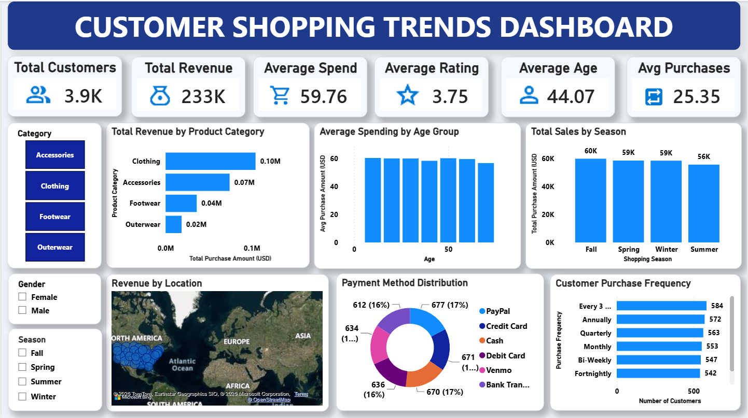

Fig: Customer Shopping Overview Dashboard

Analysis

Customer shopping data was analyzed using various business metrics, including purchase amount, product categories, payment methods, gender, season, subscription status, and customer location. Interactive visualizations were developed to compare revenue across different dimensions and identify patterns in customer purchasing behavior. The analysis also evaluates the impact of discounts, payment methods, and seasonal demand on customer spending. These findings help businesses understand purchasing trends and optimize their marketing strategies.

Insight

The analysis reveals that customer purchasing behavior varies significantly across product categories, seasons, and customer demographics. Certain product categories generate higher revenue and are better candidates for promotional discounts to increase sales. Seasonal trends and preferred payment methods also influence customer spending patterns, enabling businesses to design targeted promotional campaigns and improve customer engagement.

Chart Observation

The dashboard highlights differences in customer spending across various categories, locations, payment methods, and seasons. Revenue distribution indicates that a small number of product categories contribute significantly to overall sales, while customer demographics and seasonal demand influence purchasing behavior. These insights help businesses optimize pricing strategies, improve promotional planning, and enhance customer satisfaction. The visualizations also reveal variations in purchase amounts across different customer groups, enabling businesses to identify high-performing categories and regions with stronger sales.

Payment method analysis provides insights into customers' preferred transaction options, while seasonal trends help identify peak shopping periods. Additionally, the dashboard allows decision-makers to evaluate the impact of subscription status and promotional offers on customer spending, supporting more effective marketing campaigns and inventory planning. Overall, the dashboard provides a comprehensive view of customer shopping behavior and serves as a valuable tool for strategic business decision-making.

CUSTOMER SEGMENATATION & BUSINESS INSIGHTS

Objective

The objective of this dashboard is to segment customers into meaningful groups using K-Means clustering and analyze their purchasing behavior based on age, spending patterns, locations, and shopping preferences. The dashboard helps organizations identify high-value customer segments, understand the key factors influencing customer behavior, and develop targeted marketing campaigns to improve customer retention and business profitability. It also enables businesses to evaluate customer loyalty, identify customers with similar purchasing characteristics, and understand the relationship between demographics and shopping habits.

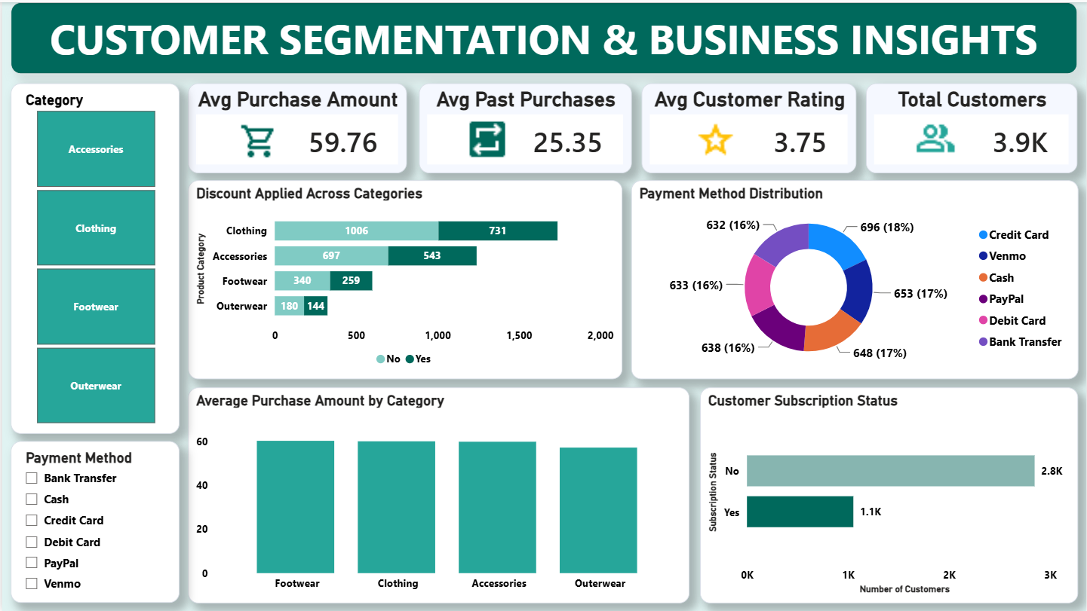

Fig: Customer Segmentation & Business Insights Dashboard

Analysis

Customer data was preprocessed and analyzed using the K-Means clustering algorithm to group customers with similar purchasing characteristics. Factors such as age, purchase amount, shopping frequency, previous purchases, payment methods, and locations were examined to identify dominant customer segments. Interactive dashboards were developed to visualize customer clusters and compare spending behavior across different customer groups, enabling businesses to understand customer preferences more effectively.

Insight

The analysis identifies distinct customer segments with different purchasing behaviors and spending habits. High-value customers demonstrate higher purchase frequency and spending, while other segments exhibit moderate or occasional purchasing patterns. These findings enable organizations to design personalized marketing campaigns, improve customer engagement, and allocate business resources more effectively.

Chart Observation

The dashboard clearly illustrates the differences between customer segments based on spending behavior, demographics, and purchasing frequency. Each cluster represents customers with unique characteristics and shopping habits, allowing businesses to identify loyal customers, frequent buyers, and price-sensitive customers. These observations support customer-centric marketing strategies, improve retention efforts, and contribute to sustainable business growth. The cluster visualizations also highlight variations in purchase amounts, previous purchases, age groups, and shopping preferences across different customer segments.
Some customer groups exhibit higher spending and frequent purchases, while others demonstrate occasional buying patterns or greater sensitivity to discounts and promotional offers. By comparing these segments, businesses can identify high-value customers, understand the dominant factors influencing purchasing decisions, and develop personalized marketing campaigns for each customer group. The dashboard also enables decision-makers to allocate marketing resources more effectively, strengthen customer relationships, and improve overall business performance through targeted customer engagement strategies.

BENEFITS OF THE PROJECT
This project provides valuable insights into customer purchasing behavior using data analytics techniques, enabling organizations to better understand their customers and make informed business decisions. By identifying meaningful customer segments, businesses can develop targeted marketing strategies, improve customer engagement, and enhance overall customer satisfaction.
The project helps organizations identify high-value customers, analyze spending patterns, and understand customer preferences across different product categories. These insights enable businesses to optimize product offerings, personalize promotions, and allocate marketing resources more effectively, leading to increased sales and improved customer retention.
Additionally, the analysis reveals the impact of factors such as age, gender, location, payment methods, subscription status, and seasonal trends on customer purchasing behavior. This allows businesses to design customized marketing campaigns, improve inventory planning, and respond more effectively to changing customer demands.
Furthermore, the project supports strategic business decision-making by applying customer segmentation through the K-Means clustering algorithm. The identified customer groups help organizations understand different buying behavior, predict future purchasing trends, and implement customer-centric strategies that maximize long-term business growth.
The project also enhances decision-making efficiency by transforming raw customer data into meaningful insights through SQL, Python, Machine Learning, and Power BI. Interactive dashboards allow business managers to monitor key performance indicators, evaluate customer trends, and make data-driven decisions with greater accuracy and confidence.
In addition, the project promotes efficient customer relationship management by enabling organizations to identify loyal customers, improve customer retention strategies, and increase overall business profitability. The practical application of data analytics and machine learning techniques demonstrates how businesses can leverage customer data to gain a competitive advantage and achieve sustainable growth.

CONCLUSION
The Customer Segmentation project successfully analyzed customer shopping behavior using data analytics, machine learning, and visualization techniques. The dataset was collected, cleaned, preprocessed, and analyzed to identify meaningful patterns related to customer demographics, purchasing behavior, spending habits, product preferences, payment methods, subscription status, and seasonal shopping trends. Interactive Power BI dashboards enabled effective visualization and interpretation of the analytical results.
The analysis revealed that factors such as customer age, location, purchase amount, shopping frequency, product categories, and payment methods significantly influence purchasing behavior. The application of the K-Means clustering algorithm successfully grouped customers into meaningful segments based on similar characteristics, allowing businesses to identify high-value customers, loyal customers, and price-sensitive customer groups. These insights support the development of personalized marketing strategies and improve customer relationship management.
Additionally, the study highlights the importance of data-driven decision-making in today's competitive business environment. Understanding customer preferences and purchasing patterns enables organizations to optimize product offerings, improve promotional campaigns, enhance customer retention, and allocate business resources more efficiently. Customer segmentation also helps businesses predict future buying behavior and respond effectively to changing market demands.
The insights generated from this project can assist organizations in improving customer engagement, increasing sales, optimizing marketing strategies, and enhancing overall business performance. Decision-makers can leverage these findings to implement targeted campaigns, strengthen customer loyalty, and maximize long-term profitability.
Overall, this project demonstrates the practical application of SQL, Python, Machine Learning, and Power BI in transforming raw customer data into meaningful business insights. It provides a structured, data-driven approach to understanding customer behavior and supports informed decision-making that contributes to sustainable business growth and competitive advantage.

